# Data Centric RAD

## Lab 1 MySQL Review

### Part 1

* Get superheroes.sql from Moodle.
* Start Wamp by double-clicking on the Wamp icon on the desktop.
* Then click on the Hidden Icons button, and the Wamp Icon.



* Then click on the MySQL console as shown, and when asked for a password just press ‘Enter’.

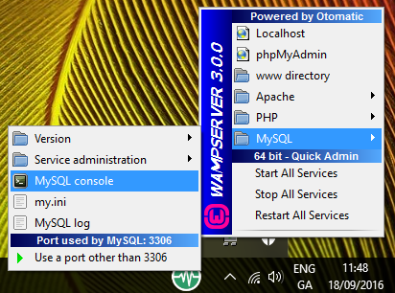

* Import the database into MySQL as follows:
  + Open the Command Prompt
  + In the Command Prompt type:

cd \wamp\bin\mysql\mysql5.6.17\bin

* + Then type:

mysql -u root -p < "***Full Path***\superheroes.sql"

Where ***Full Path*** is the location of the superheroes.sql just downloaded.

* use superheroes;
* List all tables in the database.
  + Show tables
* What is the Primary Key of the superhero_no_PK table?
  + It has no primary key
* Show all the rows and columns in the superhero_no_PK table.
  + Show * from superhero_no_pk
* List all details of all superheroes whose name begins with *S.*
  + *SELECT * FROM superhero_no_pk WHERE name LIKE “S%”;*
* List all superheroes whose Real Surname contains the letter *n.*
  + *SELECT * FROM superhero_no_pk WHERE real_name LIKE “%n%”;*
* What is the Primary Key of the superhero_no_PK table?
  + Concatenated key made of name and city fields
* List all the details of all superheroes in the superhero_2_pk table who are male (have *man* as part of their superhero name), and who are from Gotham City. The following column names should be displayed: HERO, city, First Name Alias, Last Name Alias.
  + SELECT name as HERO, city, real_first_name as `First Name Alias`, real_surname as `Last Name Alias` FROM superhero_2_pk where city = ‘Gotham City’;

### Part 2

* Get employeesDB100.sql from Learnonline.
* Import it into MySQL using the procedure described in Part 1.
* use employees;
* List all tables in the employees database.
  + Show tables;
* List all Departments.
  + SELECT FROM departments;
* List **only the name** of the Department d005.
  + SELECT dept_name FROM departments WHERE dept_no = d005;
* List all salaries greater than or equal to 101,000, but use an alias called **money** to display the results.
  + SELECT emp_no, salary as Money FROM salaries where salary > 101000;
* List all employees who were hired in 1987.
  + **SELECT** * **FROM** employees **WHERE** YEAR(hire_date) **=** 1987;
* List all employees who were hired in 1987 but were born in the 1960s or later.
  + **SELECT** * **FROM** employees **WHERE** **YEAR**(hire_date) = 1987 **AND** **YEAR**(birth_date) >= 1960;